70th Constitutional Day on 26th Nov 2019
On the occasion of constitutional day NSS - II & III conduct an awareness programme on Indian Constitution. We present a Power Point Presentation on history of our constitution and we play a video which tells about fundamental duties. After presentation we and our students take a pledge to respect and follow the fundamental duties.
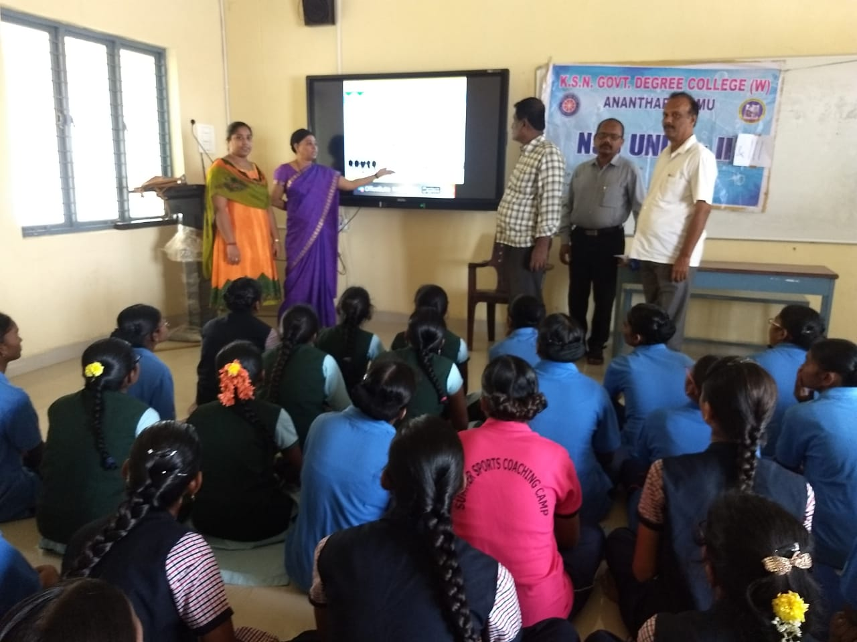
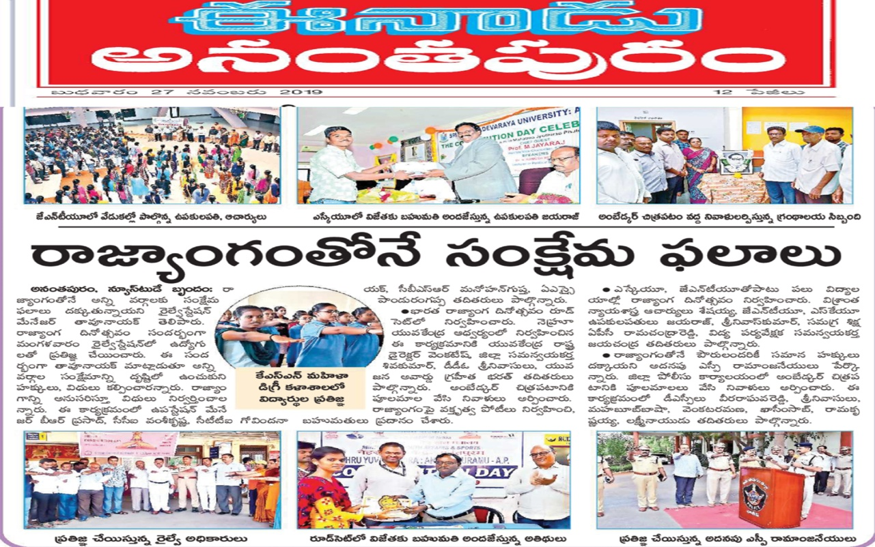
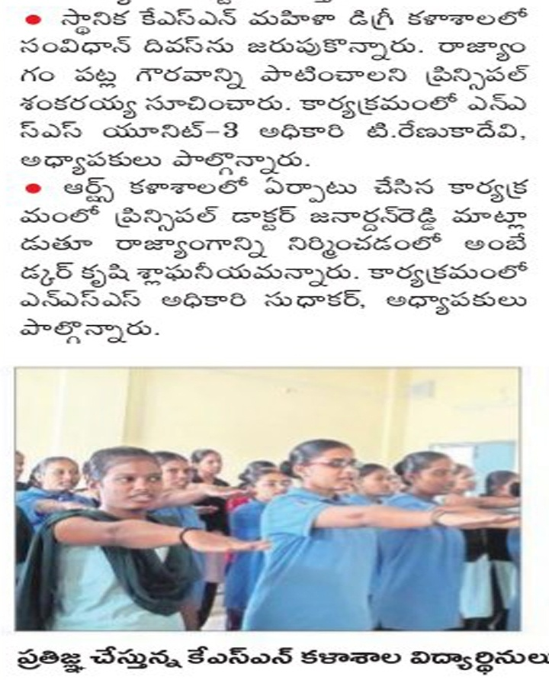
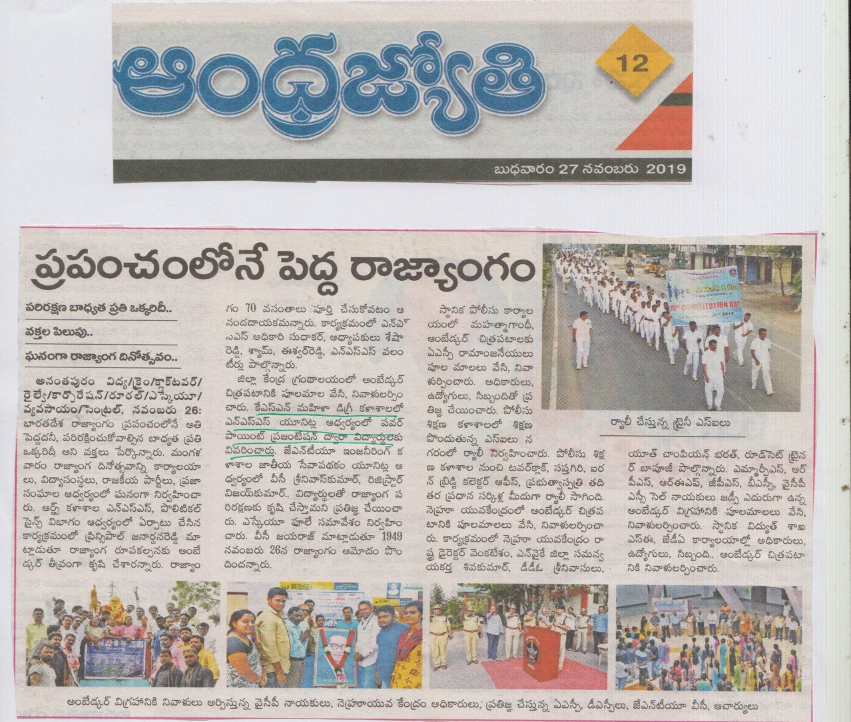
Power Point Presentation on Fundamental Duties
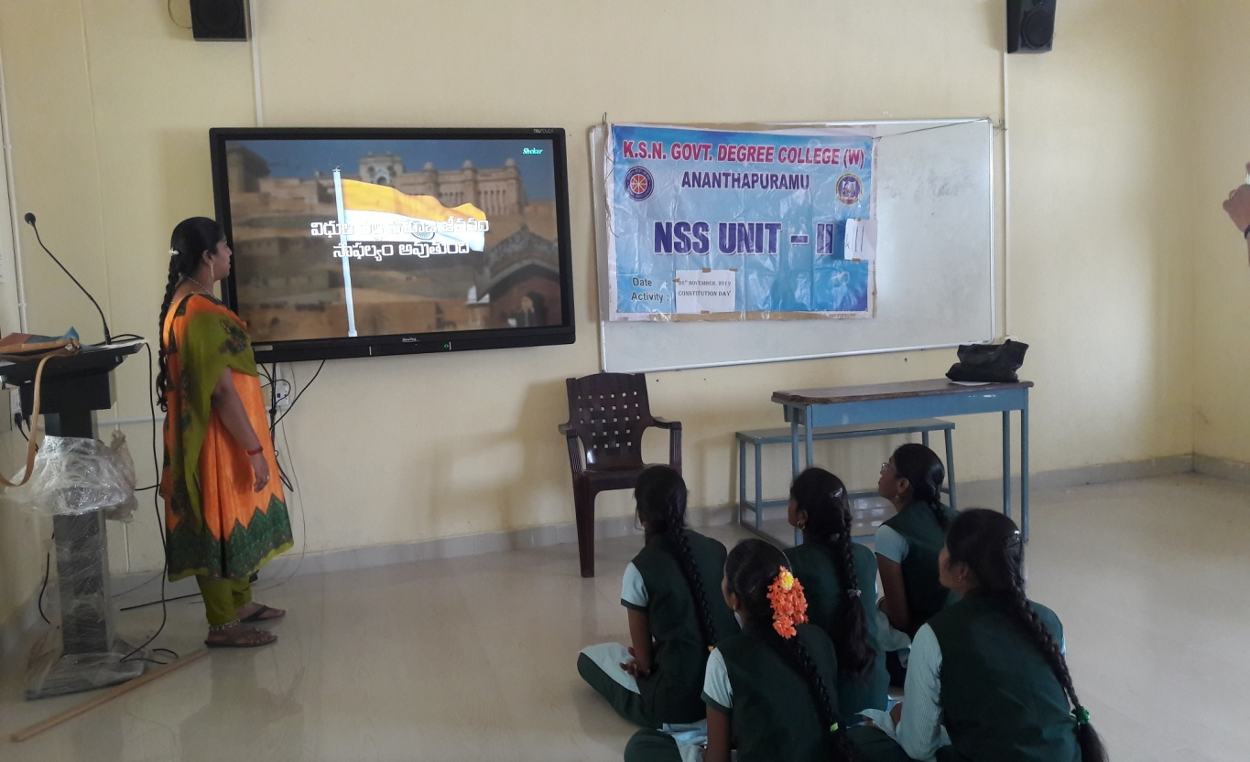
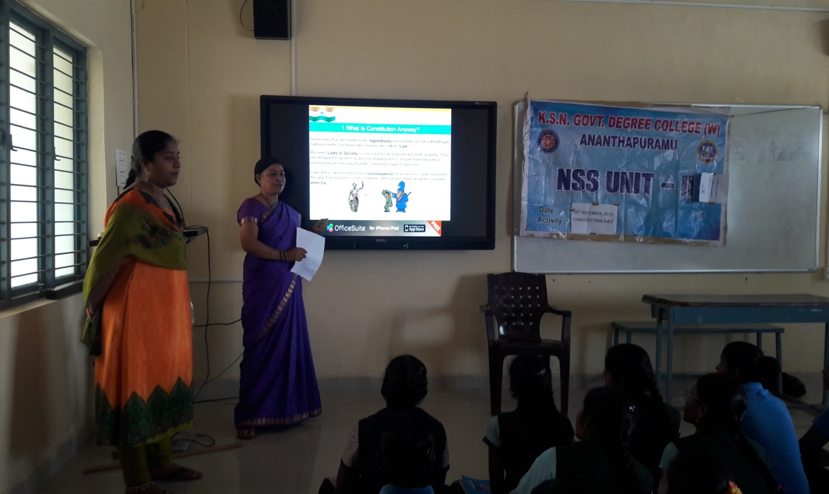
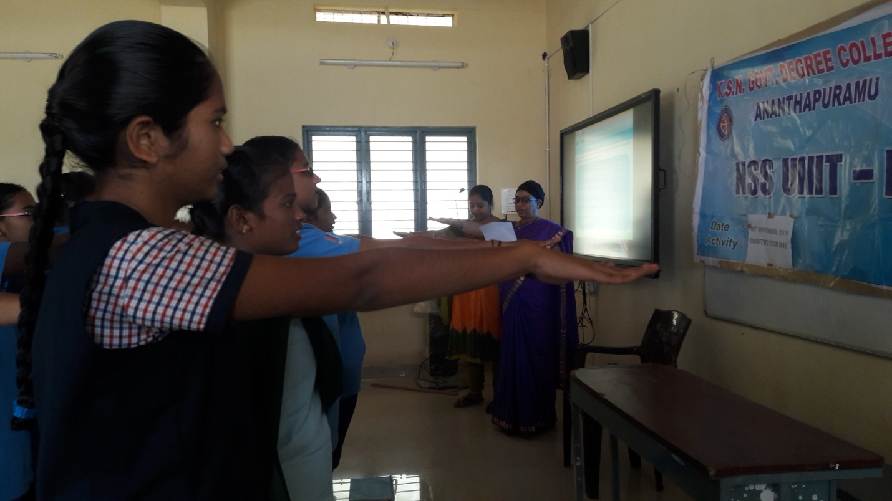
Take a pledge on Constitutional Preamble
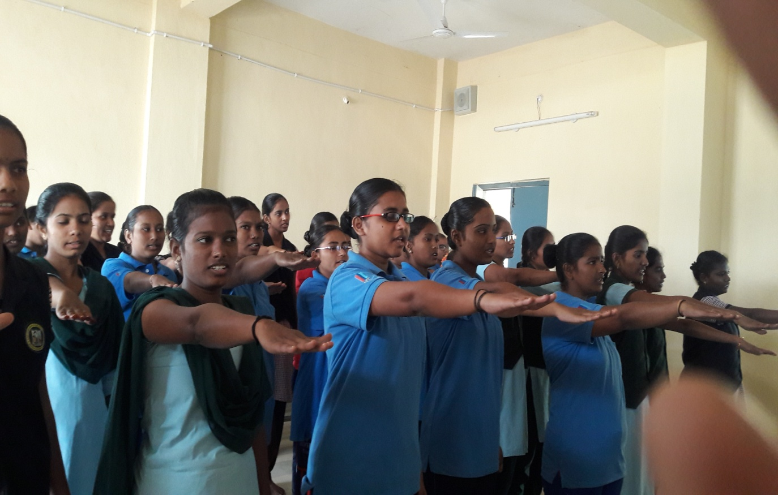

AIDS Day Rally on 1st Dec 2019
On 1st Dec 2019 International AIDS day NSS Units conduct rally from Govt. College for men, Anantapur to SSBN Degree College by NSS Volunteers.

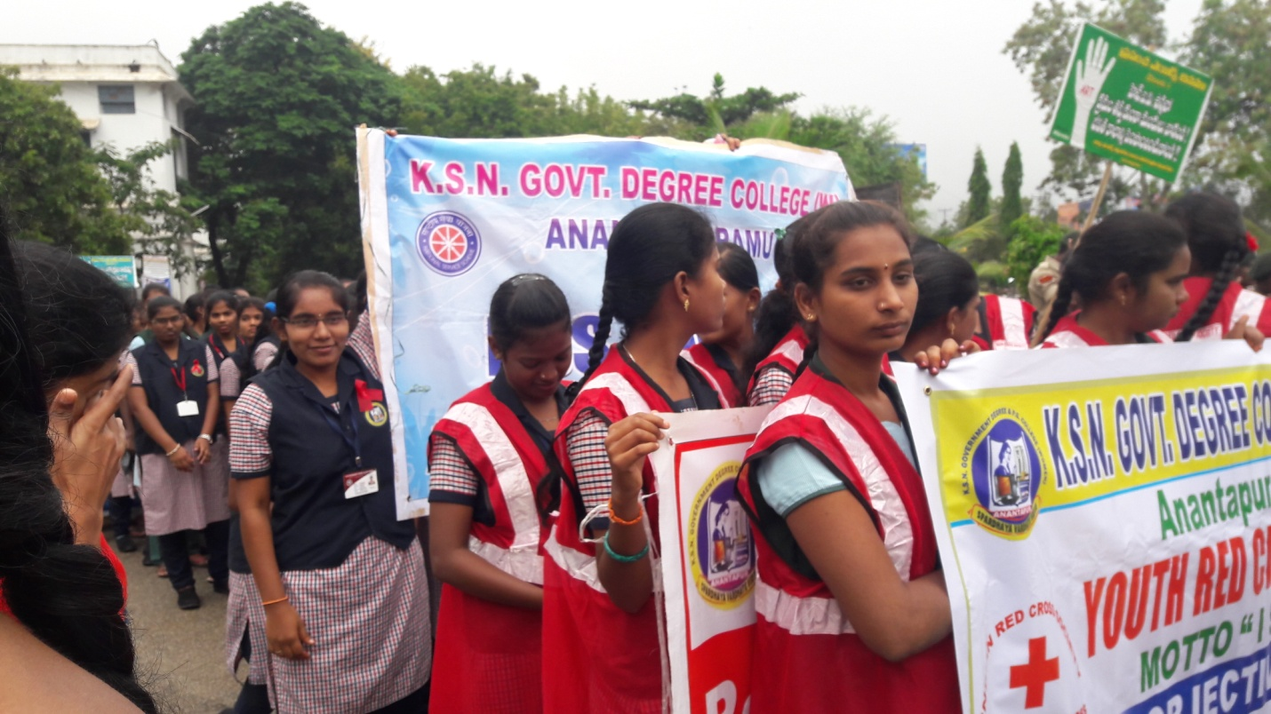
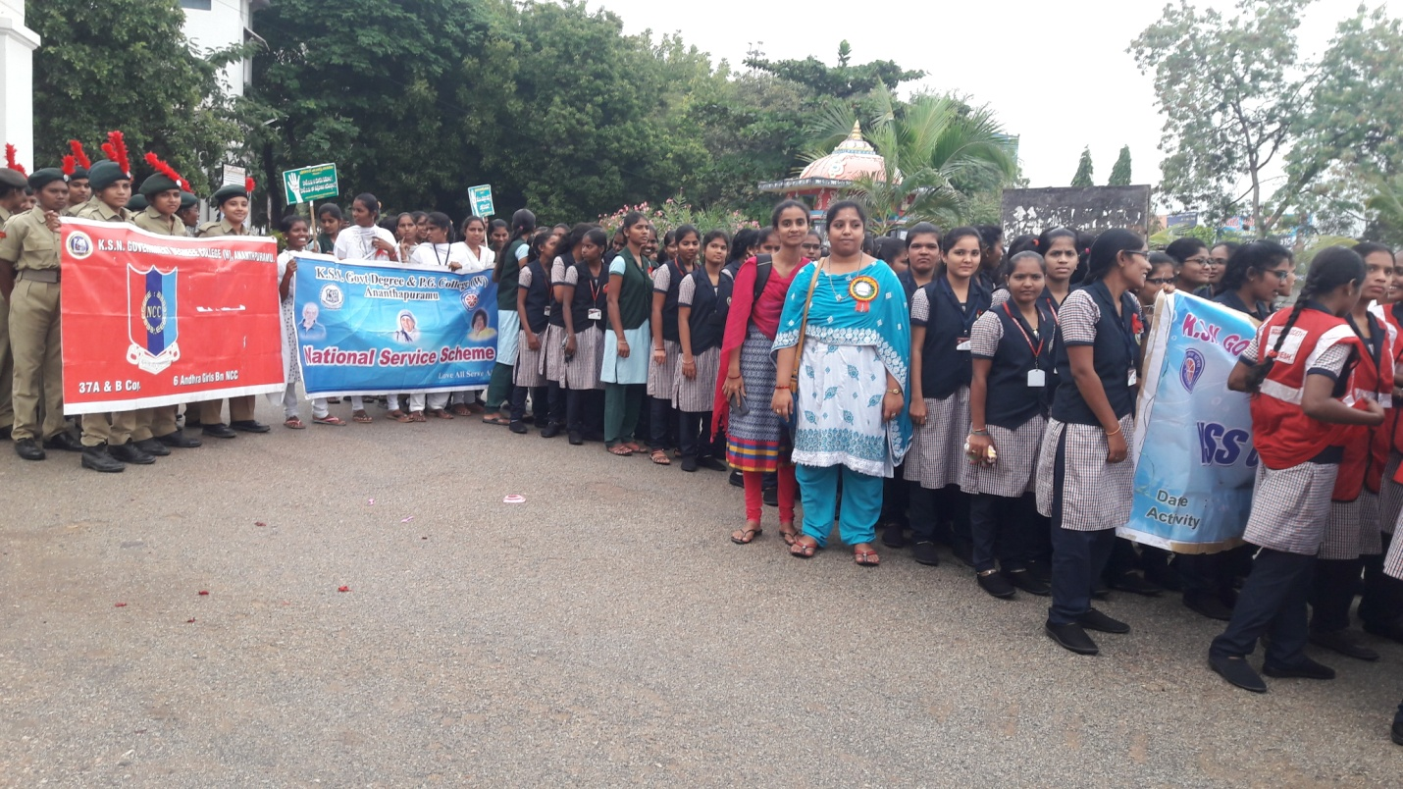
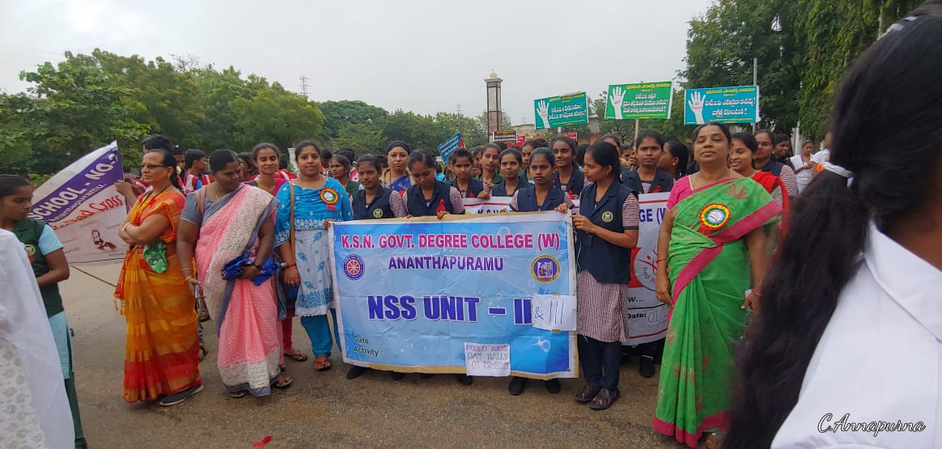
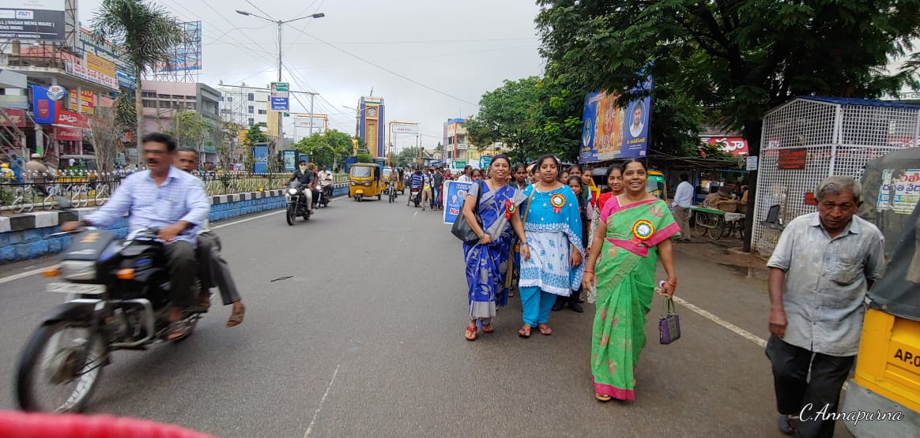

31st National Road Safety week from 11th to 17th January 2020
On the occasion of 31st road safety week all the NSS and NCC units in our college conducts a Three days training and awareness programme on Road safety drive from Jan 8th to jan 10th 2020 by Honda company.
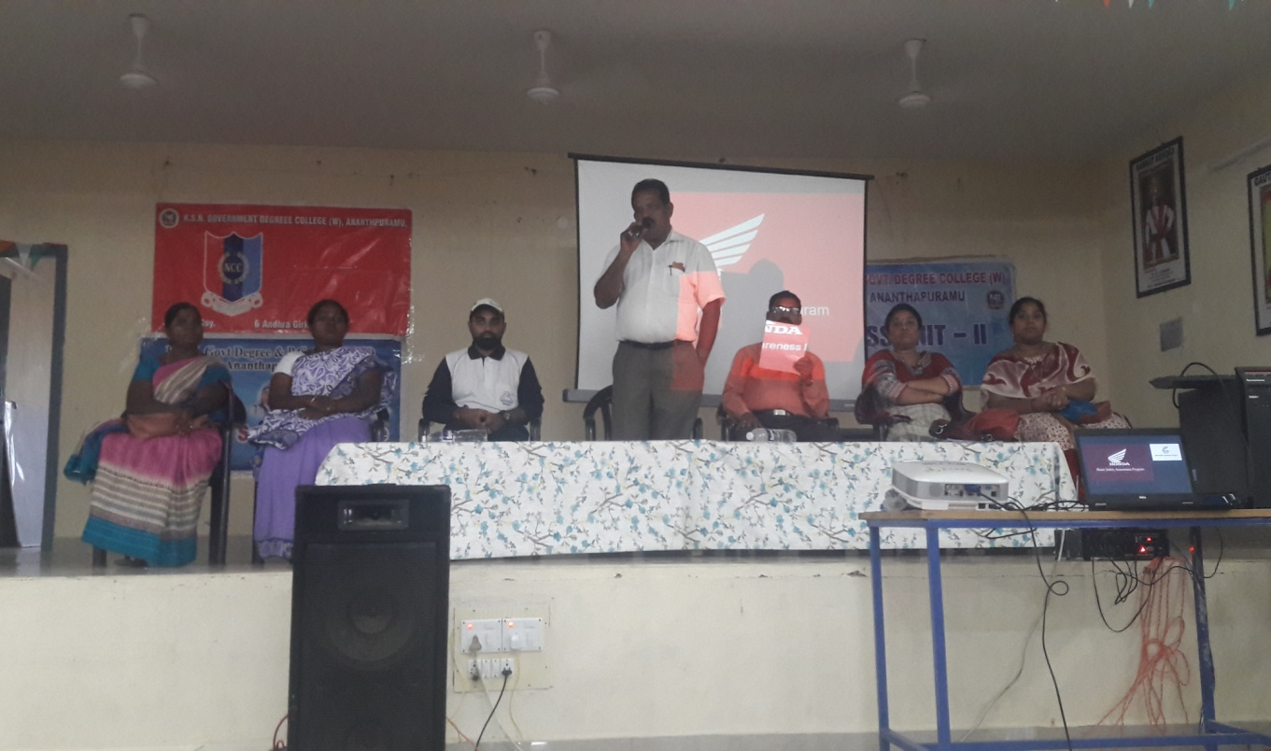
Inaugural session for the 3-days training programme by Honda company
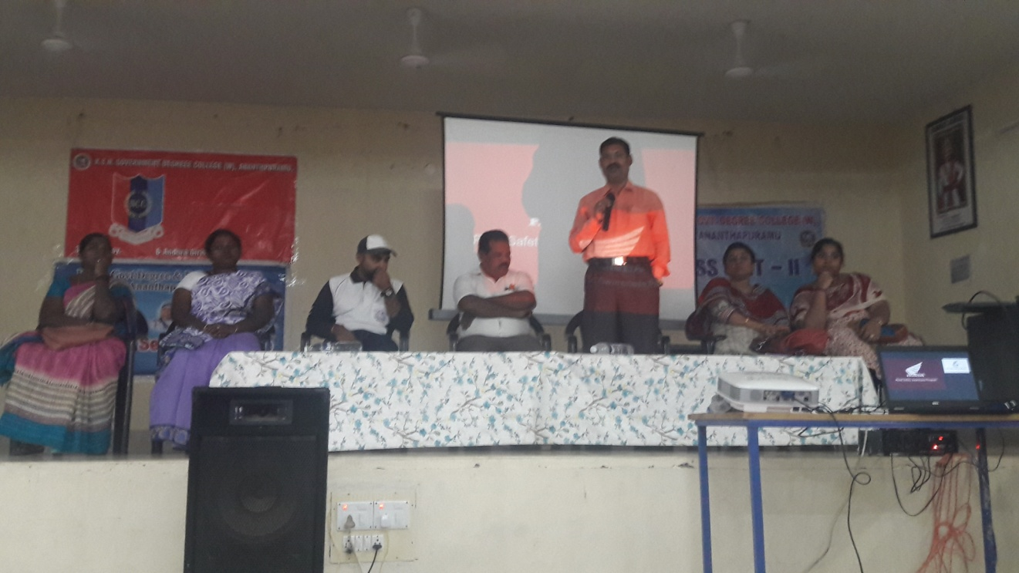
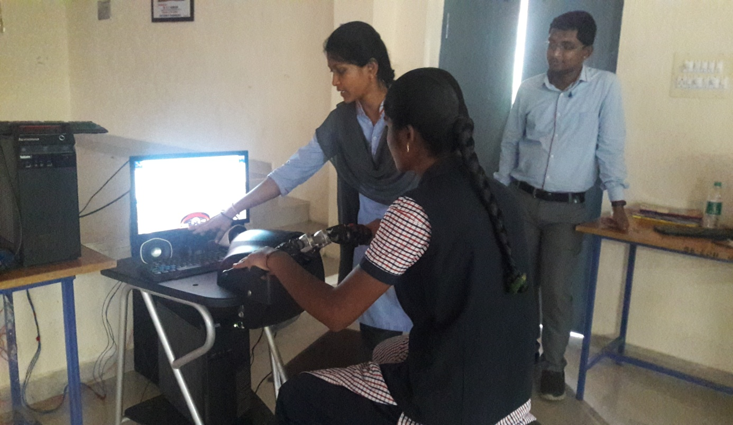
Virtual driving programme to create awareness to students
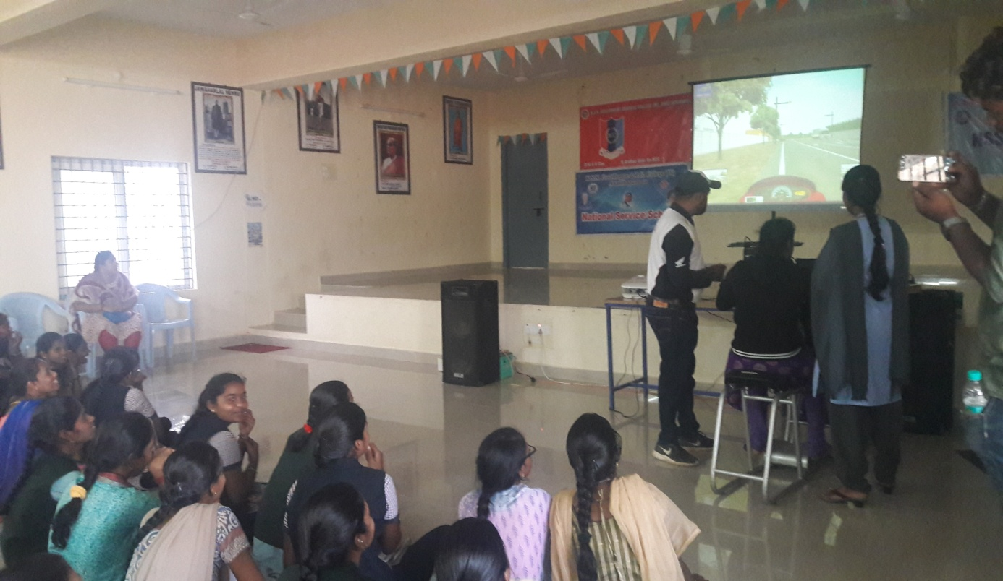
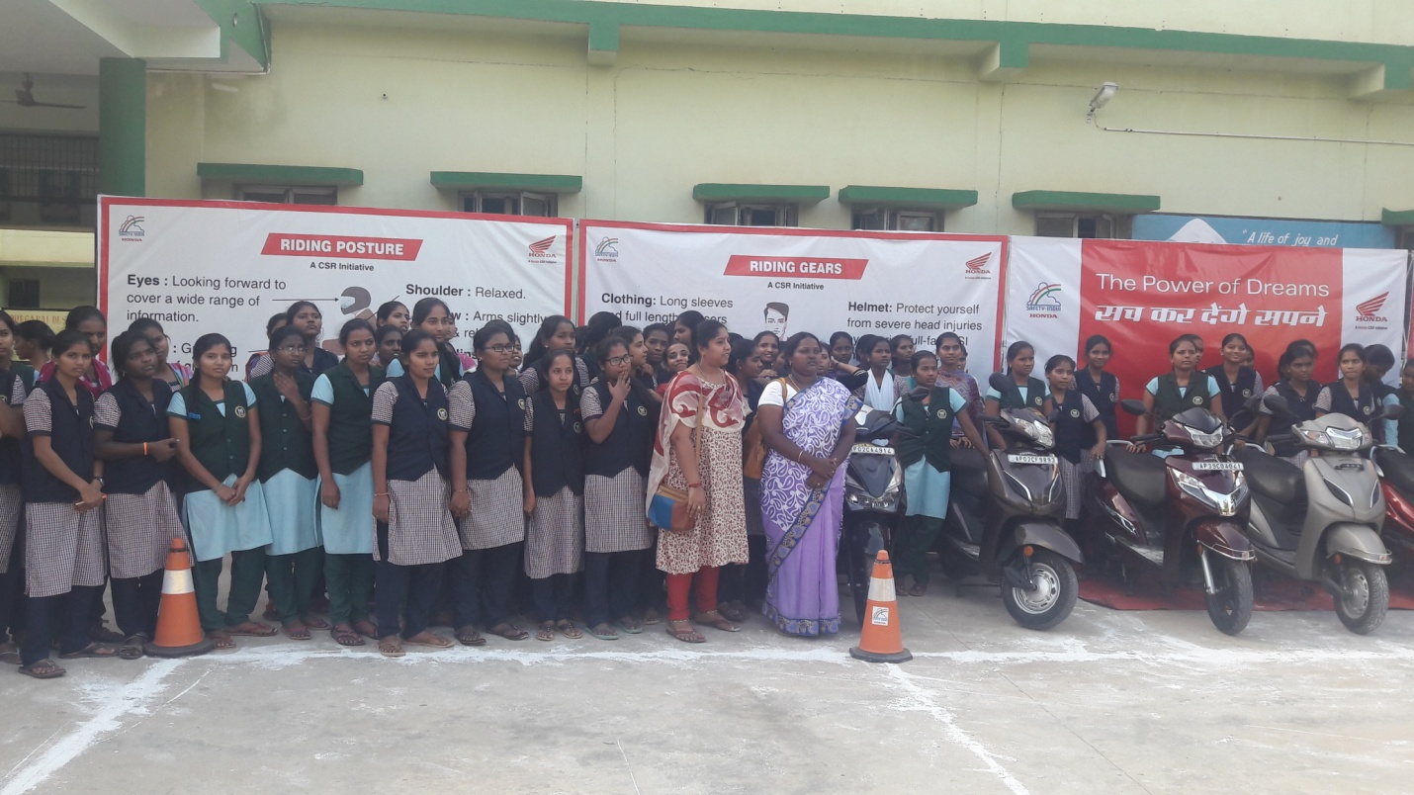
Explaning techniques in safe driving and give training to drive 2 wheeler in safety measurements
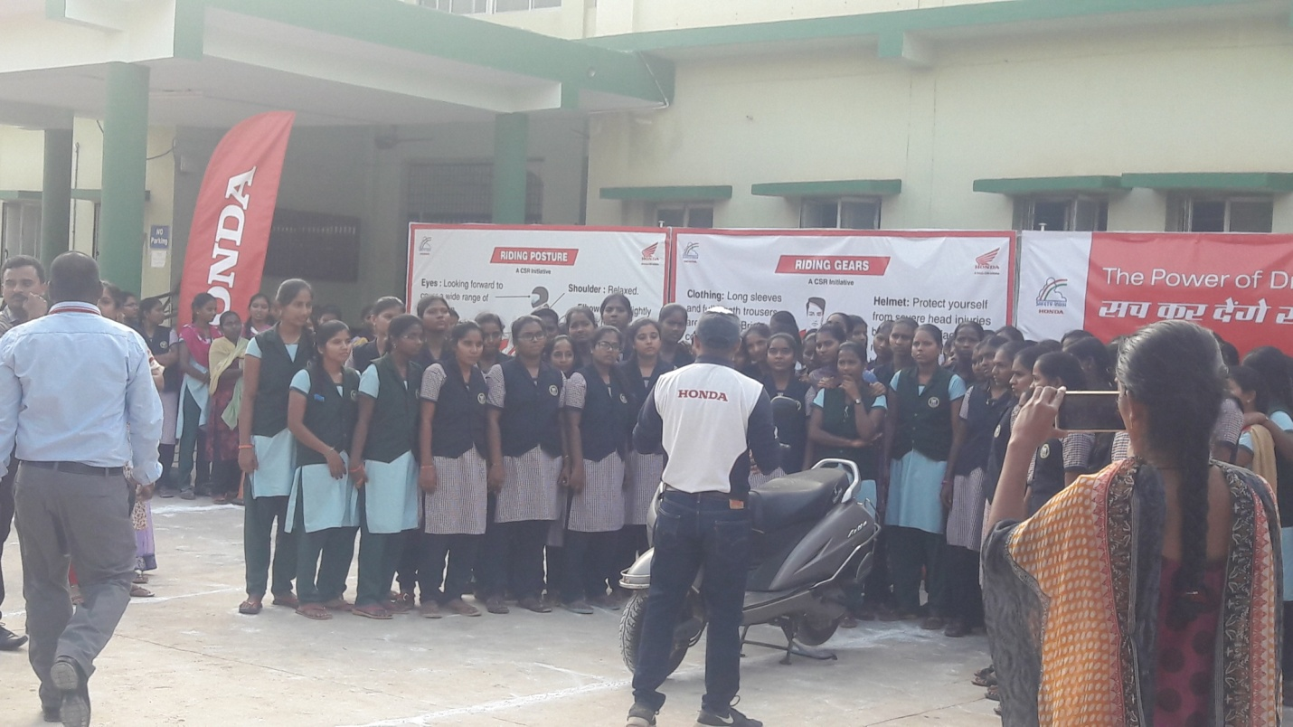
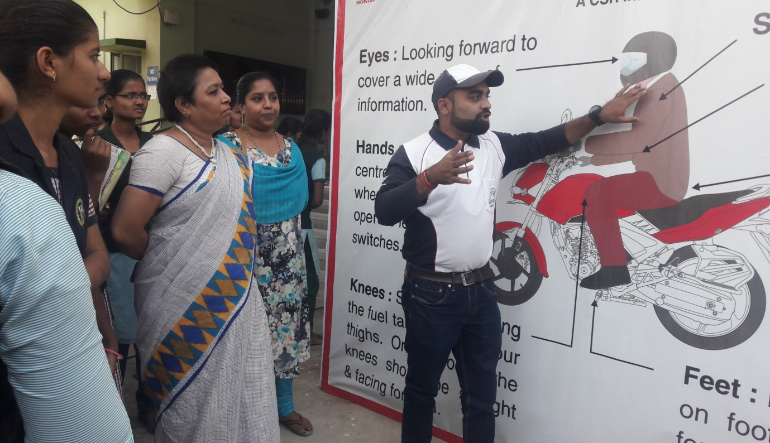
Explanation about Signals and symbols
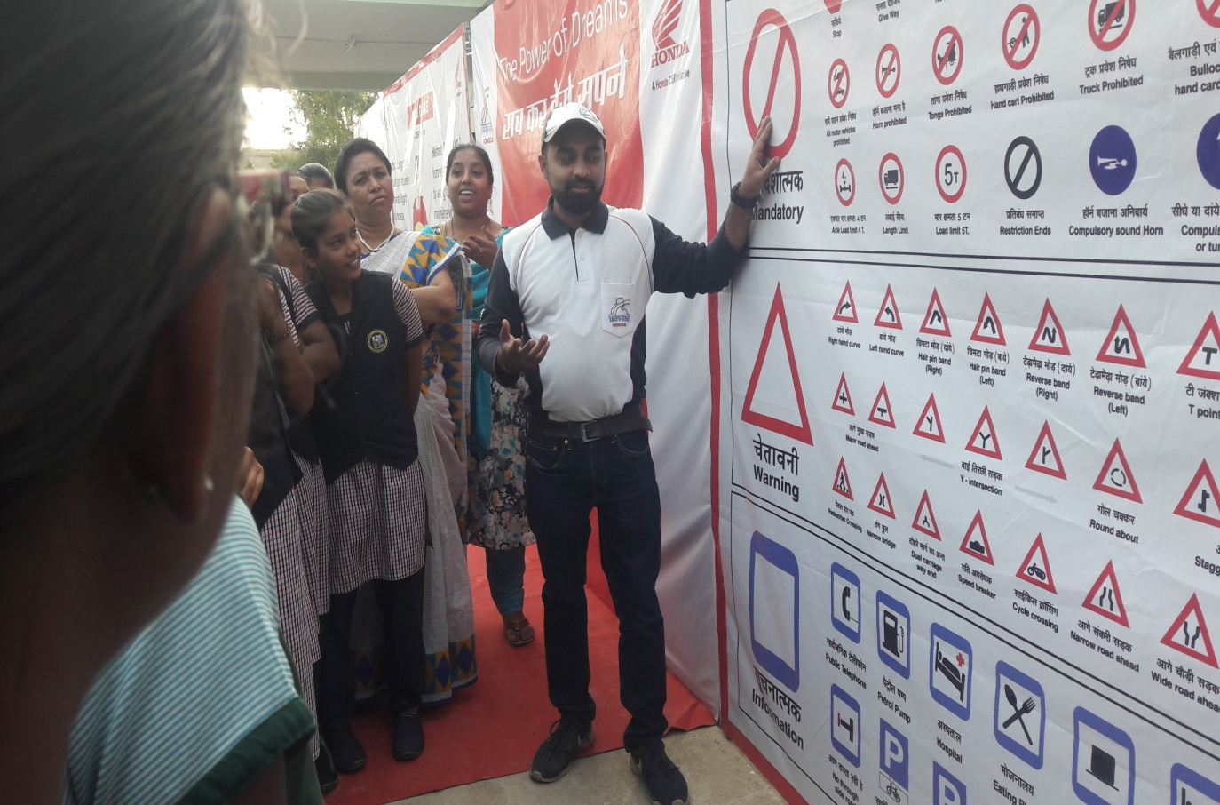

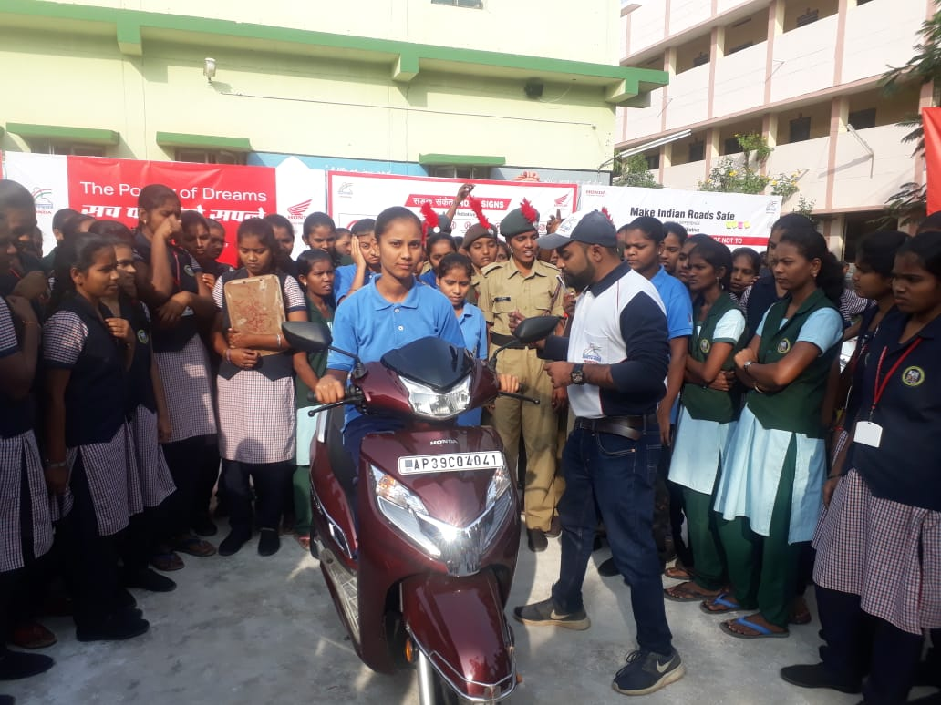
Students drive 2 wheelers under the guidance of Honda trainers
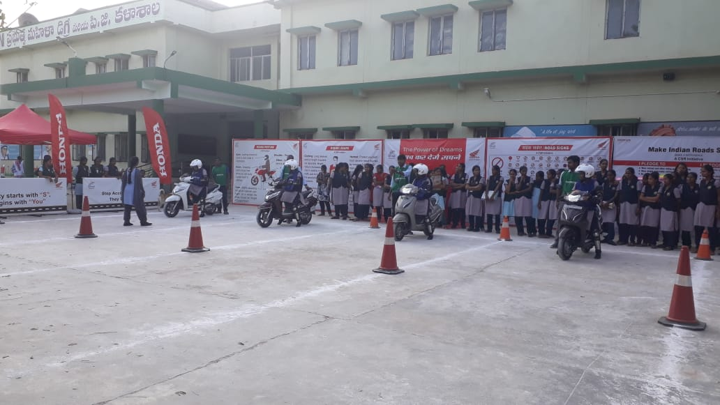

National Girls Child Day 24th Jan 2020
NSS units -II & III conducts National Girl Child Day on 24th jan 2020. In this occasion we create the awareness among students about all the inequalities faced by the girl child in the society. We play a video which shows how the girl child face the problems in society and how to overcome that problems by educate people. Also some students talk about the real problems faced by a girl in daily life.
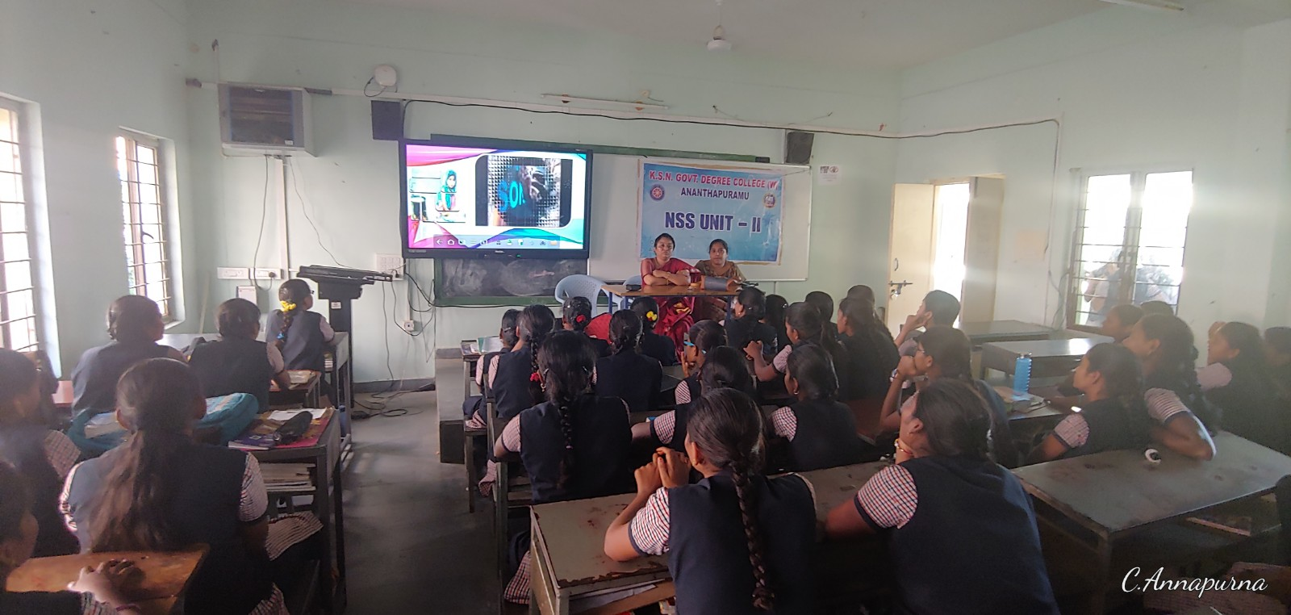
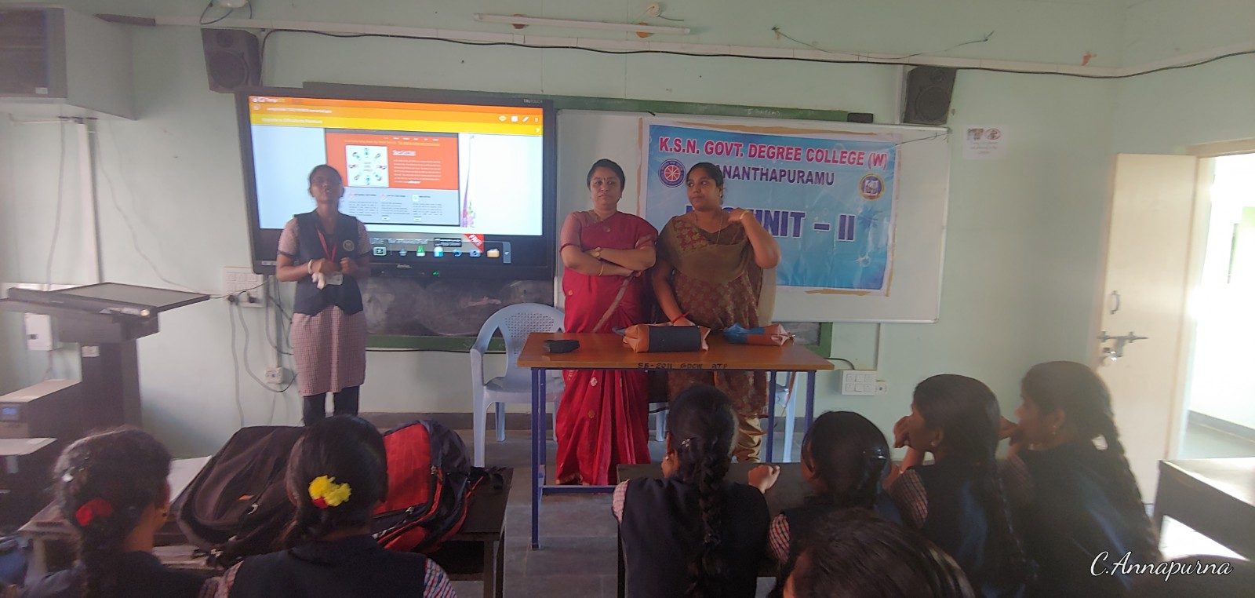
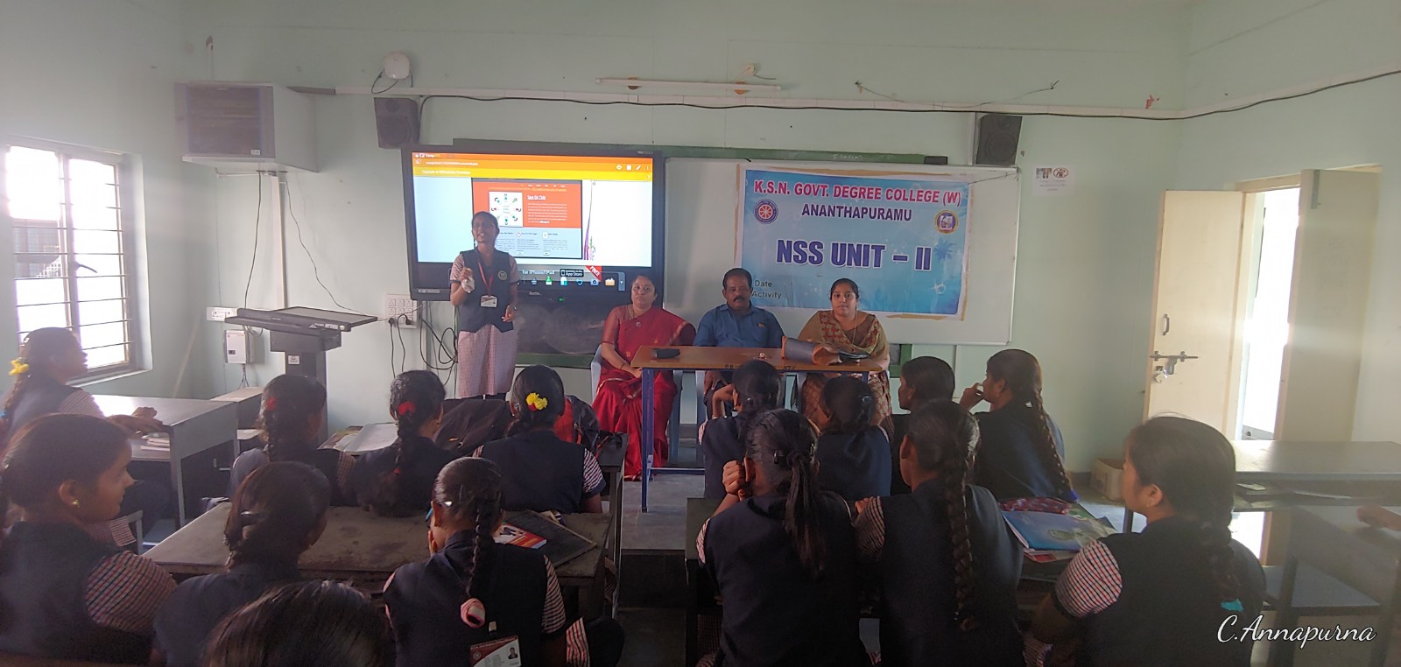
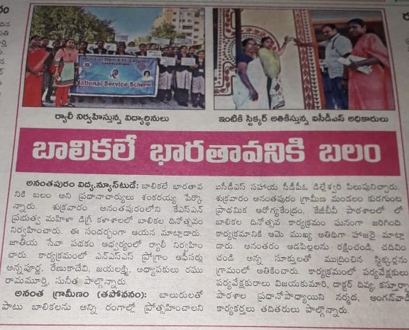
National Voters' Day on 25th jan 2020
All NSS units in our college conducting an awearness programme on National voter’s day. AISF, SFI leaders partisipate and create awearness to the student on vote.
